News & Notes

Richmond Presbyterian Church
Deep with God, Wide with the World June 14, 2020

Be sure to check out our webpage at www.richpres.com
for more information about worship services or online programs
and how we can share in your faith journey.

Please join us in congratulating our Graduates:
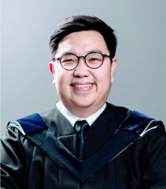
Samuel Andri just graduated from Masters of Arts (Theological Studies) program at Vancouver School of Theology. Next, he is going to continue his study for a Master of Divinity as a Presbyterian student preparing for church ministry. It will be another 2.5 – 3 years of full time study and discernment. He is thankful to Rev. Victor Kim and RPC community for shaping him in many ways and helping him to understand about PCC much better.

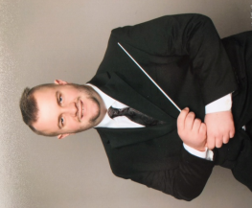
Andrew Whiteside graduated from Trinity Western University in May 2020. He received a bachelor’s degree from the Faculty of Arts majoring in music. He studied piano, voice, choir, conducting and timpani in his program. He plans on continuing his studies in music and pursuing a career in this field.

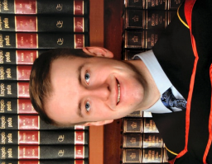
Darren Whiteside graduated from the University of British Columbia in May 2020. He received a bachelor’s degree from the Faculty of Engineering majoring in computer engineering. He plans to pursue a career in software engineering and travel in the future.

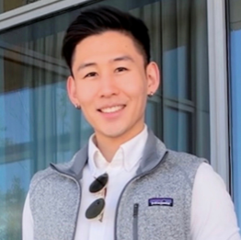
Jacob Kim graduated from the UBC Sauder School of Business with a major in Finance. He is currently working at an investment fund as an intern and is looking forward to further pursuing his career in finance.

___________________________________________________________
The Rev. Dr. Hans Kouwenberg, Moderator of the 133 General Assembly of the PCC and former minister of Calvin Presbyterian Church, Abbotsford, and well known to many at RPC, died this week in Vancouver. We extend our prayers to his wife Colleen and their family.

How to financially support the ministry of RPC

- Pre-Authorized Remittance Program (PAR). Contact Heather to sign up.
- e-Transfer through online banking: use this email richpres.givings@gmail.com for e-transfers.
- Credit Card: donations can be made through Canada Helps please use the following link:
https://www.canadahelps.org/en/charities/richmond-presbyterian-church/

Richmond Presbyterian Church

LEAD MINISTER Rev. Victor Kim
ASSISTANT MINISTER Rev. Young Tae Choi
MUSIC DIRECTOR Jannie Burdeti
DIRECTOR OF CHILDREN Anne-Marie Ellithorpe
& YOUTH MINISTRIES
CUSTODIAN Christie Rolick
ADMINISTRATIVE ASSISTANT Maureen Natusch

www.richpres.com | 604-277-5410 | richpres@telus.net

